**Snowy Mountains Back Country  
Application Report:** MOD DA 10174 March 2022

**Background:**

A Development Application has been granted for the use of a kiosk and areas of the Guthega Ski Centre by Snowy Mountains Back Country (‘The tenant’) for the purpose of operating a food and beverage premises. The existing application did not consider the use of external parts of the building as a component, however upon further review it has been determined that the use of the existing balcony area will create considerable amenity and views for guests to the premises. Images of the balcony area and connecting exterior walkways are provided at Appendix A of this document.

Modifications to existing Development Applications may be requested per §4.55 of the EP&A Act. In particular, the provisions of 1A are relevant to this application, being a *modification involving minimal environmental impact.*

The applicant requests the following changes to DA10174 in association with this modification request:

**The Requested Modifications:**

* **Amend *Approved Development* to provide for seating of 110 patrons.**
* **No amendment required to condition F.3 – seating of 110 patrons is consistent with the BCA allowance for the premises.**
* **Amendment to condition F.8 *hours of operation for café*, subject to existing limitations regarding the Liquor Licenceto provide for the following:** 
  + 1. **7.30AM – 5PM seven-days a week.**
    2. **Extended late trading hours until 11PM three-days a week (Fri-Sun).**
* **Amend condition F.9 *Balcony* to provide that *access onto the balcony must be restricted to mitigate any risks to the public, consistent with the snow management plan for the building.*** 
  + **A general description of the snow management plan between PBPL and Snowy Mountains Back Country is provided below.**

**Seating:**

The applicant has determined that there is sufficient capacity to seat 110 patrons indoors within the licence area with consideration to the relevant BCA and Health requirements. The proposed amendment does not require modification of the plans or SEE associated with DA10174.

**Operating Hours:**

*Seven-Days a week:*The applicant is committed to contributing to the year-round economy of Kosciuszko National Park and seeks the capacity to operate throughout the year. This will provide services to visitors to Guthega who currently have a reduced number of offerings available to them.

It is noted that the Development Assessment Report and Conditions provide that variation may be allowed through written approval by the Secretary, or a nominee; and that this may be desirable in the future. It is the preference of the applicant to seek approval through this modification.

*Provision for extended trading:*The provision for extended trading, to take place up to three-days a week has been included to allow for flexibility of operations in association with SMBC’s broader operations and is not anticipated to have amenity or noise impacts due to the nature of the premises (Café) and Liquor Licence limitations.

**Use of Balcony:**

The existing north-west-facing balcony provides access indoors to the Guthega ski centre via sliding door, with egress also available via two walkways connecting to the balcony to the north-east and south-west of the centre. The balcony has a mesh grate floor surface and a substantial, BCA-compliant balustrade. The south-western aspect is most prone to snow accumulation. Images of the balcony area and connecting exterior walkways are provided at Appendix A of this document.

For fire and emergency egress reasons, it is necessary to have at least two safe points of egress from the balcony structure. This is generally satisfiable by reliance on the sliding doors and walkway to the north-east; however, snow may accumulate from time-to-time on the north-eastern and south-western aspects of the building.

**Compatibility with NPWS Referral:**

The proposed changes to DA10174 do not relate to the existing commentary provided by NPWS or associated conditions. The changes are therefore considered compatible with the previously stated views of the referral agency.

**Addendum to SEE:**

This addendum to the existing Statement of Environmental Effects associated with DA10174 has been created to formalise the proposed snow management arrangements associated with use of the balcony and reflects the Snow Management Plan in effect between Snowy Mountains Back Country and Perisher Blue Pty Ltd. (‘PBPL’), who own the building and operate the surrounding ski field.

The applicant seeks a condition associated with the modification which reflects the amended snow management plan, that is that use of the balcony will be prohibited in the event of snow fall or accumulation making access and egress from the balcony unsafe via the north-western exit.

*Proposed Substitution for ‘Snow Deposition’ section of SEE assoc. with DA10174 – Stamped 9 Mar 2020:*

**Snow Management Plan**

Generally, the tenant is responsible for maintaining clear access to and from the entrances of their premises.

In entering into a sub-lease of the premises, the tenant undertakes to:

* Ensure that access doorways, stairs and balconies are clear of snow and ice so that they are safe to access.
* Particularly, ensure that the north-east facing walkway and north-west facing balcony are kept clear of snow and ice accumulation between the building wall and balustrade to deter snow-drifting.
* Ensure that deck surfaces are generally maintained at an even grade that ensures sufficient balustrade height.
* Prevent access to the premises or unsafe parts thereof where they are rendered unsafe until they are made safe.
  + This may be due to a snow height of over 500mm; icing-over of the surface, or adverse weather.
  + Specifically, prevent access to the balcony area by locking sliding doors to balcony and rope-off north-east and western walkway access.
* Contact the Mountain Operations division of PBPL where it becomes impractical to satisfy the above conditions due to heavy snowfall or snow accumulation from wind.
  + PBPL will send resources to mechanically clear the access points to the premises and the deck as soon as practicable.
  + The north-western deck can accommodate a snow groomer of the type used in the area.
  + PBPL will use methods and techniques consistent with its typical mountain safety practices to make safe and provide access as appropriate, such as the use of fencing, signage, and verbal instruction.

Practically, it is anticipated that the balcony will rarely be unsafe during a typical winter season, due to the aspect of the balcony and deck meaning it will be subject to high solar loads, the nature of snow accumulation in the area largely being driven by wind and snow-drifting, and the mitigations proposed in the snow management plan.

**Consideration of Proposal against Clause 1A of §4.55**

The consent authority may, on application being made, modify an existing consent provided the following provisions are satisfied:

1. *It is satisfied that the proposed modification is of* ***minimal environmental impact***  
   The impacts associated with the modification are no greater than those associated with the existing consent.
2. *It is satisfied that the development to which the consent as modified relates is* ***substantially the same development*** *as the development for which the consent was originally granted and before that consent as originally granted was modified (if at all)*  
   The changes sought in association with this application are minor in nature; they do not propose changing the types of activity permitted by the existing consent or require substantial alteration to existing development and management plans for the premises.

Clauses (c)-(d) are not applicable to this application.

**Appendix A: Images**

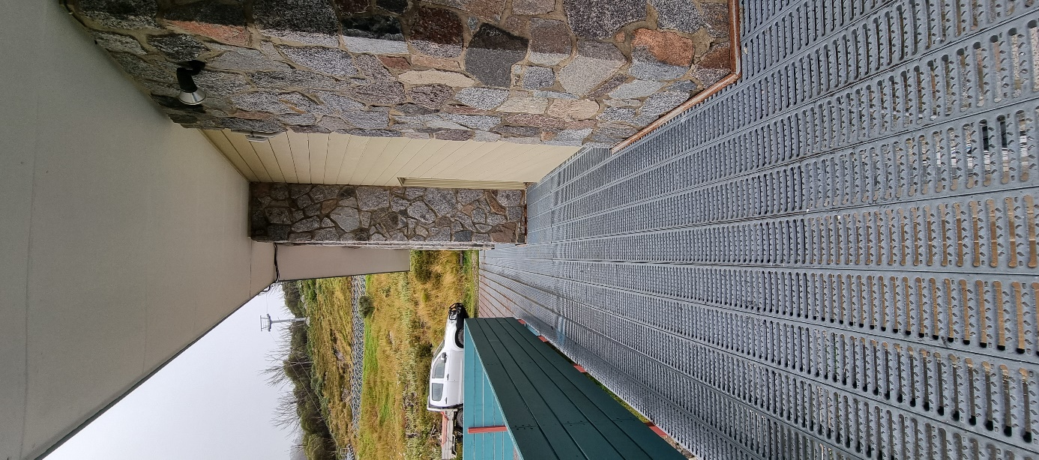

*Balcony to North-Eastern Walkway View of North-Eastern Deck and Walkway  
& Deck. to Balcony.*

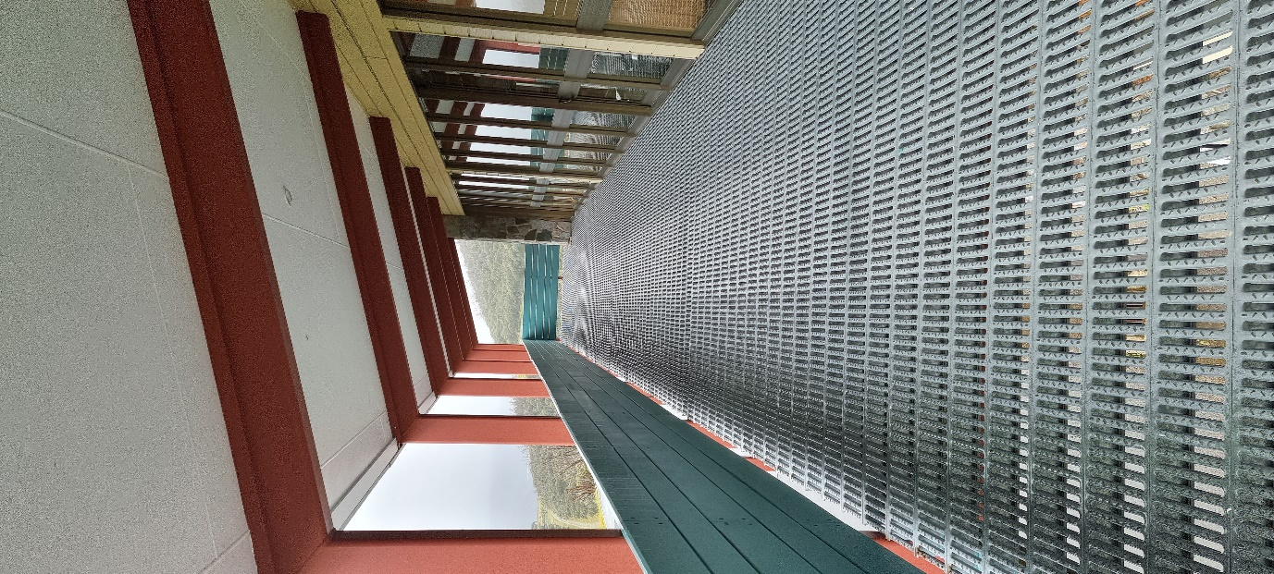

*Balcony to South-Western Walkway & View of Balcony facing to North-Eastern Walkway.  
Access door.*

**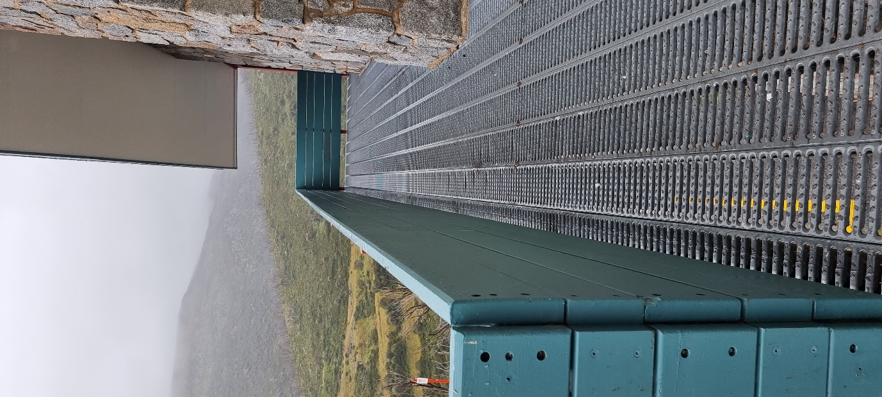***View of South-Western Walkway and Rail  
Connecting to Balcony.*